**USN NUMBER: 1RVU22BSC074**

**NAME: Prince Ranjan**

|  |  |
| --- | --- |
| **Ex No: 6.1**  **Date: 10-09-2024** | **Auto Encoder on MNIST Dataset using TensorFlow** |

**Objective:** To build and train a simple autoencoder using the MNIST dataset that compresses the input data and reconstructs it using the encoded latent representation.

**Descriptions:** This lab involves the implementation of an autoencoder, which is a neural network designed to learn a compressed, encoded representation of the input data. The MNIST dataset of handwritten digits is used for training and testing. The images are flattened into vectors of size 784 (28x28 pixels), normalized, and passed through the network. The encoder reduces the dimensionality, and the decoder reconstructs the original image from the encoded representation.

**Model:** The model consists of:

* **Input layer:** 784 units, representing a flattened image.
* **Encoder:** A dense layer with 64 units and ReLU activation, compressing the input into a lower-dimensional space.
* **Decoder:** A dense layer with 784 units and sigmoid activation, reconstructing the image.

· The loss function used is **binary crossentropy**, and the optimizer is **Adam**.

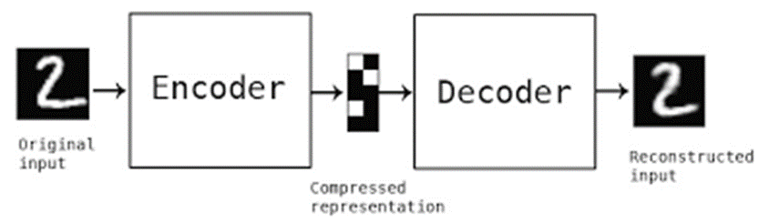

**Results:** After training for 50 epochs, we evaluated the model on test data. The encoder successfully compressed the input into a latent representation, and the decoder reconstructed the input from this compressed version.Visualization of the input, encoded, and decoded images shows that the model effectively captures and reproduces the basic structure of the input digits.

**Conclustion:**

The autoencoder performed well in reducing the dimensionality of the MNIST images and reconstructing them with minimal loss. This experiment demonstrates the use of autoencoders for unsupervised learning, where the goal is to learn efficient representations of data without labels.

GitHub Link: https://github.com/princeranjan789